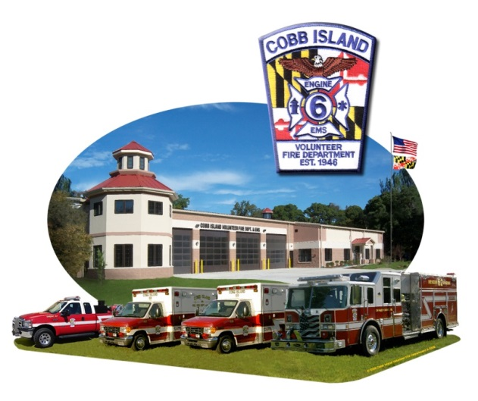

COBB ISLAND VOL. FIRE DEPT.,
EMS & AUXILIARY
17069 Cobb Island Road, Cobb Island, MD.

FIRE PREVENTION OPEN HOUSE
Eat Lunch with the Members of CIVFD !

Sun., OCT. 25, 2015

12:30 – 1:00 p.m. Lunch
1:00 – 2:00 p.m. Demonstration Stations
(EDITH, Stop, Drop and Roll,
Call 911 Smoke House)

Demonstrations also for the LUCAS CPR Device!

2:00 – 3:00 p.m. Fire Prevention Movies &
Puppet Show

Refreshments served.

Remember: Nov. 1, 2015 - Clocks turn back &
Change the Batteries in Your Smoke Detectors!

For information, call 301-259-2730

